task 1 :- scan your local network for open ports using nmap
- finding local ip range
- on our computer go to command prompt
- type ip config
- observe and note down local ip addreass ,subnetmask, and default gateway
- from these find your local ip range
- local ip range 10._._.4 to 10_._.145

- performing tcp syn scan for -ss 192.168.1.0/24
- 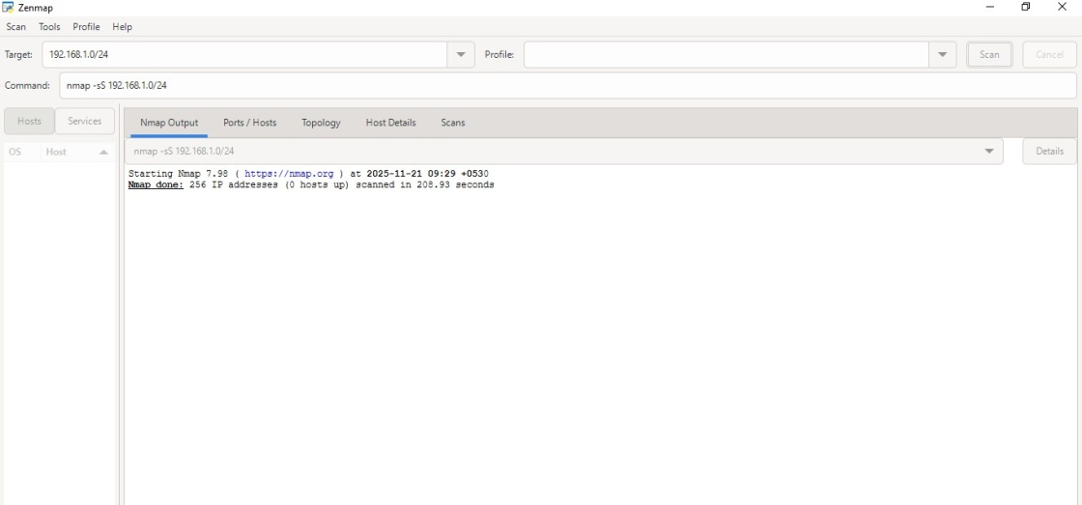

- port state service version
135/tcp open msrpc microsoft windows rpc
139/tcp open netbios-ssn microsoft windows netbios-ssn
445/tcp open microsoft-ds?
5357/tcp open http microsoft httpapi httpd 2.0 (ssdp/upnp)

- common sevices of above ports

port 135 — rpc (remote procedure call) / dcom
- protocol: tcp/udp
- used for:
  - inter-process communication between windows services
  - endpoint mapper (epm)
  - required by many windows components (e.g., wmi, active directory)
- security note:
often targeted by malware (e.g., blaster worm) because it allows remote system interaction.
- port 139 — netbios session service
- service: netbios session (netbios over tcp/ip)
- protocol: tcp
- used for:
  - legacy windows file sharing
  - network browsing
  - smb traffic on older systems
- security note:
vulnerable and outdated. should be disabled on modern systems.
- port 445 — smb (server message block)
- service: microsoft-ds / smb direct over tcp/ip
- protocol: tcp
- used for:
  - file sharing (\shared-folder)
  - printer sharing
  - active directory communication
  - windows authentication
- security note:
  - exploited by eternalblue (wannacry ransomware)
  - highly targeted in attacks
  - should not be exposed to the internet.
- port 5357 — wsdapi (web services on devices)
- service: windows wsd (web services discovery)
- protocol: tcp
- used for:
  - device discovery (printers, scanners)
  - web services for devices api
  - peer-to-peer device communication
- security note:
not commonly attacked, but can expose device information.
- potential security associated with open ports 135, 139, 445, and 5357—

port 135 — rpc (remote procedure call) risks

main risks
- remote code execution (rce) vulnerabilities
  - worms like blaster exploited rpc dcom on port 135.
  - allows attackers to execute commands remotely.
- information leakage
  - rpc endpoint mapper reveals running services, aiding recon.
- used in lateral movement
  - attackers use rpc to interact with services like wmi.

port 139 — netbios risks

main risks
- smb enumeration
  - attackers gather information:
    - usernames
    - shared folders
    - os version
    - domain info
- session hijacking / man-in-the-middle
  - netbios is not encrypted; sniffing is easy.
- brute-forcing network credentials
  - old smbv1 authentication mechanism is weak.

port 445 — smb (server message block) risks

main risks
- high-profile rce exploits
  - eternalblue → wannacry, petya ransomware
  - smbghost vulnerability
  - allows attackers to gain full system control.
- unauthorized file access
  - attackers access shared folders without proper permissions.
- pass-the-hash attacks
  - smb can be used to authenticate using stolen ntlm hashes.
- lateral movement
  - tools like psexec use smb for remote execution.

port 5357 — wsdapi (web services on devices) risks

main risks
- device information leakage
  - reveals printer/scanner/device metadata
  - helps attackers map the network.
- man-in-the-middle attacks
  - wsd communication is often unencrypted.
- potential dos
  - attackers flood wsd services to disrupt discovery.
- unauthorized device access
  - if misconfigured, allows access to printers or iot devices.

- Analyzing packets capture with wireshark
UDP PACKETS
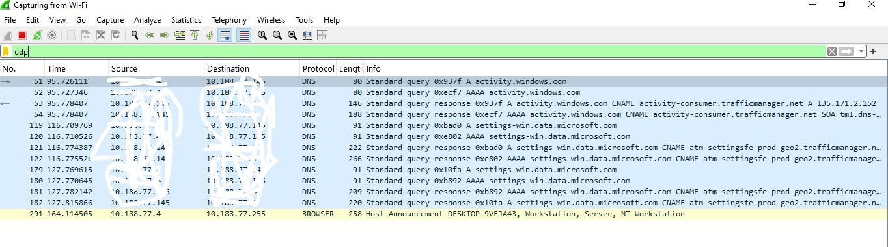

TCP PACKETS
